KissanDoc- The Smart Farming App
Abstract:
In India, 35% of the annual crop is lost due to plant diseases. Plant disease is important for increasing crop production. To solve such problems, we have created a smartphone application KissanDoc. There is an integration of a chatbot (AgriBot) which will provide farmers 24x7 support and guidance. Our solution KissanDoc addresses the main challenge in the agricultural field i.e. plant disease and however, aim is to solve it using technology. The app uses ML techniques to predict plant diseases from the photos captured by the user and recommend the appropriate measures. Along with disease prediction, this app recommends suitable crops for farmers to yield based on weather, rainfall, temperature, and humidity. The data set collected is from Kaggle which consists of images mainly focusing on 4 classes: Grape, Tomato, Potato, and Corn along with a real dataset collected from the farmers of the villages. The goal is to empower farmers, to identify plant diseases early, make the appropriate decisions, and increase their crop productivity.
Keywords:
Plant disease, crop recommendation, Machine learning, KissanDoc, AgriBot

- Introduction:
Agriculture is the economic sector globally. India is a developing country with agriculture as one of the main occupations. As 50% of the population has agriculture as its main occupation, farmers follow traditional cultivation methods.[1]. Agriculture is an important field in the world. Along with providing food, it is also considered one of the major sources of income for most developing countries, such as India. [2]. In India, 35% of the annual crop is lost due to plant diseases. Plant disease is important for increasing crop production. The idea is to develop an application that is useful for farmers and reduce their dependencies. To solve such problems we have created a smartphone application KissanDoc and in that system, there is an integration of a chatbot (AgriBot) which will provide farmers 24x7 support and guidance.
- Objectives:
- To enhance agriculture productivity by doing early disease detection and suitable crop recommendations.
- To implement machine learning techniques for accurate crop disease prediction and recommend farmers the suitable crop to yield.
- To develop an automated smartphone application (KissanDoc) to help farmers.
- To provide 24x7 support and guidance to the farmers using an AgriBot.
- Related Work:
In this section, an overview of recent research [3] was to analyze the use of ANN on plant disease based on the plant leaf diseases, plant pests, growth or quality of the plant or crop, and agricultural products. ANN was used to detect and classify the diseases on the leaves of agricultural plants, namely apples, cotton, corn, and many more with high-accuracy training results. The references were used by criteria needed through the media in the network: Research journal search, Journal Search results, data preprocessing, and data analysis. Along with ANN many models (DCNN, CNNvector quantization, detected,3D models) are used according to their uses. Results obtained under different categories: 1. agricultural plant disease is the best model with the highest accuracy of 99%. 500 images of tomato leaves obtained 4 diseases on tomato leaves with the CNN model. CNN achieved 98.8% accuracy on maize and coffee leaf diseases. 2. agricultural plant pests DCNN is best with an accuracy of 99%. Out of 705 images of strawberries that were observed as Carolina geranium (anti-oxidant or anti-bacterial), 88 positive images and 109 negative images were obtained. 3. plant growth or quality of plants 3D model was accurate. 4. agricultural product ANN was the best model with 98% accuracy. Results of plant diseases were obtained from the dataset of tomatoes which comprises the 7176 images in which 10 diseases were obtained. 3663 images of tomato and apple leaves were also used as input for the ANN. 150 images of coffee leaves were used as input for CNN. The training was carried out with 14810 input images and 400 images for testing for weed or pest detection. To classify and identify plant pests the no. of inputs from the faster R-CNN training was 75000 images and 500 images were selected for iteration to produce 5 classes of insect pests. The leading objective of this research [4]was to enhance the value of automatic fruit disease detection. It proposed an efficient smart farming technique that diagnosed and classified external diseases within fruits. The purpose was to supervise the disease on fruit and suggest alternate solutions for healthy yield and productivity. Three fruits namely grapes, apples, and pomegranate been used for this research. The system used image processing techniques for implementation. Open cv library was applied for implementation, the k-means clustering method was applied for image segmentation, and the images were mapped to their respective disease categories based on four feature vectors (color, morphology, texture, structure of hole on the fruit). ANN was used for pattern matching and classification of disease. Image processing solution was proposed for the detection of grape (black rot, powdery mildew, downy mildew), apple (apple scab, apple rot, apple, blotch) and pomegranate (bacterial blight, aspergillus, fruit rot, gray mold diseases) fruit diseases are detected and classified. Once diseases were detected proper treatments were suggested accordingly. Further study involved promoting Indian farmers to do smart farming which helped to make time-to-time decisions which also saved time and reduced loss of fruit due to diseases. The main challenge was the limited dataset that reduced the systems' ability to generalize across different. Fruit and disease variations. The author [5] presented a review of the various factors that affect the overall production of crops and the research on the field of plant disease detection and their findings. It provides a brief study about diff. Types of diseases affecting the growth of plants and also tell about the symptoms. General steps involved in image processing: image acquisition, pre-processing of the image, image segmentation, feature extraction and selection, disease identification. A review of this research concluded that deep learning algorithm provides the best possible result while using less computational effort and requiring less amount of time for the prediction. Along with they concluded that the visual system for plants was more satisfactory than nonvisual systems. digital image processing provides more effective, cheaper, and faster results than manual analysis of plants for disease detection. They primarily focused on studying and analyzing previous research work without conducting any implementation or validation of their research. Developed a web application named Kissan Konnect- A smart farming solution [1] recommending the best crop to yield acc. to weather, soil type, rainfall, temp., humidity, and pH. The disease detection module was also one of the important features implemented, and the website offered a possible treatment for the identified illness. the system had 6 sub-modules- crop prediction, plant disease detection, tool renting, weather forecasting, fetching top 10 news headlines, and providing contacts of agencies that helped out farmers in time of need. For the plant disease detection module using Keras disease detection of leaf pictures was found, to build a model sequential API was utilized, leaf binarized was used to transform multi-class leaf disease labels to binary labels, Adam optimization was used for optimizing the results and the test achieved was 95.4%. For crop prediction decision tree classifier, random forest classifier, Naive Bayes algo., SVM and logistic regression were used. The algo. with the highest accuracy was Random Forest (95%). this feature was available in English, Marathi, and Hindi for rent tool functionality. for the climate and news, feature Rest API was used so that farmers used the tool to learn about the climate and weather forecast, which will help them plan their next agriculture activities. training model with different classification algorithms like decision tree classifier, random forest classifier, Naïve Bayes, SVM, and logistic regression, the accuracies were 90%, 99.09%, 99.05%, 97.95%, and 95.22% respectively. The future scope was a mobile-friendly application with enhanced functions that could be created in the future along with the use of payment methods which would be added for tool rental services. The various tools could be filtered based on the location. However, less data availability could lead to reduce the system's performance. Not all farmers may be familiar with using web-based applications, especially in regions with lower literacy rates. the plant disease identification module made use of the extensive dataset which included tomato, potato, pepper bell, and other plant leaves. The dataset used for the crop prediction model was made up of soil attributes such as the NPK values of soil, temperature, humidity, soil pH, rainfall, etc. E-crop Doctor [2] automatic rice which is an automatic system in the form of a smart smartphone application was proposed which detect diseases from paddy leaves which could also suggest pesticides to farmers. The application also had a chatbot named docCrop which provided 24x7 support to the farmers. the proposed methodology was divided into two parts. First to identify the best model for the detection of the disease and then apply it on the mobile application consisting of an easy-to-use interface and chatbot for help. YOLO v3 tiny and YOLO v4tiny had been employed for the development of the mobile-based rice disease detection model. The training was performed for 6000 epochs. sing the Android Studio best model deployed on the mobile application was created. the chatbot was built using a third-party API, Kommunicate. to compare YOLO v3 tiny and YOLO v4 tiny models at each step it is observed that up to 2000 epochs, the mAP% of YOLO v3 tiny is better than YOLO v4 tiny, but soon after YOLO v4 tiny performs better. This might be because of the smaller network size of YOLO v3 as it learns quickly. Lastly, YOLO v4 tiny gives a better score for all the metrics. this reveals that the mAP% of 95.38% was achieved with the YOLO v4 tiny whereas 85.43% was achieved with YOLO v3 tiny. it was observed that YOLO v4 tiny was more accurate and gave more effective results. with an accuracy of 98.13% the model was able to detect all three different diseases precisely. this model was deployesd on the mobile application in tenserflowlite format. Further, detect more paddy diseases and cover other plants also to develop it as a platform for all crops. Regional languages might be included in the chatbot to make it more user-friendly in the future. The scope was the community of farmers would also be made to discuss common issues using the application itself. the system detects only three paddy diseases. It might lag behind the capability to detect a higher range of disease. Along with it did not support regional languages which limits systems usability among farmers who might not be comfortable with the language used in the chatbot. the dataset consists of 762 images and this dataset was divided disease-wise into the ratio of 90:5:5 by employing the random split technique. Therefore, brown spot disease had 248, 13, and 14 images for training, testing, and validation respectively. Blast disease has 232, 13, 13 images and hispa disease has 206,11,12 images. the paper [6] presented a comprehensive overview of 70 studies on deep learning applications and the trends associated with their use for disease diagnosis and management in agriculture. Providing a detailed assessment and considerations for developing deep learning-based tools for plant disease diagnosis in the form of seven key questions: a) dataset requirements, availability, and usability. b) imaging sensors and data collection platforms. c) deep learning techniques. d) generalization of deep learning models. e) disease severity estimation. f) deep learning and comparison of human accuracy. g) open research topic. ANN, image classification for agricultural applications, such as plant disease identification. The object detection model was evaluated using average precision (AP) and mean average precision (mAP). Object detection identifies multiple different plant diseases and instances of diseases simultaneously with images and videos. Semantic segmentation was also a popular technique used for plant disease identification. some popular segmentation algorithms include Mask R-CNN and U-net. datasets used for plant disease identification achieved accuracies of greater than 90% which supported the hypothesis that the deep-learning model was capable of generalizing well to unseen testing data within the same dataset for plant disease identification. the accuracy for cross-dataset generalization was lower than 50%. in future developed and trained models that generalize better across different datasets. Searching for the methods for the training models that effectively performed under diverse conditions. current models often require training under controlled or pre-defined image acquisition conditions. This restricted the applicability of the models in real-world scenarios where the conditions vary. multiple datasets were used. The plantvillage data set consists of 54309 images. Another plant disease dataset called digipathos comprised 46513 images across 171 diseases affecting 21 crops. Out of which 2326 represent leaves diseases rest consist of cropped disease lesions. The PlantDoc dataset consists of 2598 images. NLB dataset consists of 18222 field images of corn disease. RoCoLe a coffee dataset consisted of 1560 images. The rice disease dataset consisted of 3355 images. cassava disease dataset consists of 5656 images. corn disease and severity dataset consisted of 4455 images. Detecting cassava diseases using 5 fine-grained cassava leaf disease categories. This paper [7] focused on techniques to achieve an accuracy score of over 93% with class weight, SMOTE ((Synthetic Minority Over-sampling Technique), and focal loss with deep CNN from scratch. the goal was to counter high-class imbalance so that model can accurately predict underrepresented classes. the proposed algorithm was CNN to build a low-cost method to detect cassava disease with the implementation steps being dataset acquisition, labeling, training the model, and testing/model evaluation using k-fold cross-validation. accuracy and mean squared error for CNN after applying techniques to counter the class imbalance, the accuracy achieved was above 93% with a loss below 10%. The model was good at predicting CMD(cassava mosaic disease), CBSD(cassava brown streak virus disease), CBB(cassava bacterial blight), and healthy classes with a precision of 96%, 93%, 93%, and 92% respectively. however, the model performed poorly on predicting the CGM(cassava green might) class with 90% precision, visually CGM looks closer to CMD. further research on multiple co-occurring diseases on the same plant. the challenge faced with this research was the size of the dataset was very small, which led the model to suffer from overfitting problems. Along with the classes being highly imbalanced and being heavily biased towards CMD, CBSD classes and images had poor resolution and low contrast. the dataset was adopted from Kaggle which consisted of 5 fine-grained cassava leaf disease categories with 10,000 labelled images [8].

The focus of this study [9]was to identify where deep learning had been used for improving various agricultural practices, to rank the topics to help new researchers in this area and to emphasize practices that could direct future research. This bibliography reviewed the potential of using deep learning in agricultural applications. A keyword-based search for these papers used the search terms deep learning and agriculture or farming. Through that query, 133 papers were obtained out of which 120 were found to be useful according to the research requirement. Major topics in deep learning for agriculture were disease detection, plant classification, land cover identification, and precision livestock farming. Later it would focus on the integration of real-time data from sensors, satellites, and UAVs. This paper [10] trained a deep CNN to identify 14 crop series and 26 diseases. Measure the performance of the model based on its ability to predict the correct crop disease pair, given 38 possible classes. AlexNet and GoogleNet were two deep learning architectures used. Evaluated the applicability of CNN for the classification of the problem. Two training mechanisms were used i.e. transfer learning and training from scratch. The trained model achieved an accuracy of 99.35%. Without any feature engineering, the model correctly classified crops and diseases from 38 classes in 993 out of 1000 images. Challenges faced were the accuracy of the model goes down significantly, about 31% just above, when tested on the images taken in different conditions from the training set. Limiting the models' ability as the training data is not diverse sufficiently. Variety and more extensive data were required to enhance the accuracy. By facing up on a homogenous background, from images of single leaves the model only classifies images. This does not deal with real-world conditions where diseases appear on different parts of the plant, differently. Analyzed 54306 images of plant leaves which had 38 class labels. Resize the images to 256x256 pixels. Used three different versions of the whole plant village dataset. Different ranges run for train test splits. For ex: 80-20(80% of the whole dataset used for training and 20% for testing ), 60-40, 50-50, 40-60, 20-80. The study [11] explored the possibility of computer vision approaches for scalable and early plant disease detection. Proposed an entirely new dataset for plant disease detection called PlantDoc. Stochastic gradient descent with a momentum of 0.9, categorical cross-entropy loss, and a learning rate of 0.001 were used for training the network. For pre-trained models, they used the weights provided in keras trained on ImageNet. Evaluated the performance of VGG16 using different training sets on PlantDoc. Along with evaluating the performance of CNN architectures on the cropped-PlantDoc dataset. for leaf detection faster R-CNN with Inception Resnet v2 network, they used momentum optimizer keeping a degrading learning rate with an initial value of 0.0006. Real-case scenarios have low accuracy when processed initially with ImageNet or PlantVillage. Faster R-CNN with Inception Resnet v2 performance was best with an mAP of 38.9. To enhance the utility of the dataset, applied image segmentation techniques to extract the leaf from images. Further development and refinement of the PlantDoc dataset for broader applications in computer vision for agriculture. Some dataset images could be wrongly classified due to a lack of extensive domain expertise and require a dataset with more images in each class for high accuracy. created a dataset by downloading images from Google Images and Ecosia. Collected a dataset of 20900 images of 38 classes. Removal of classes having less than 50 images. The total no. of classes was 27 spanned over 13 species with 2598 images. [12]To investigate the problem of plant disease recognition in the community of image processing. Constructed a dataset of 271 plants with 220592 images. Based on the different characteristics of plants, a plant disease-oriented framework for plant disease recognition was present. The framework consisted of three main stages, namely Cluster-based Region Reweighting (CRR) taking all the divided patches from plant diseases as input and setting the weight of each patch-label pair, Training with Loss Reweighting (TLR) allocating the corresponding weight to each loss during weekly- supervised training to enable the discriminative disease part learning, and weighted feature integration(WFI) utilizes LSTM to encode in a weighted patch feature sequence into comprehensive representation. validate was 89.44% and the test was 85.40% for TLR. Validate was 89.91% and test was 85.54% for WFI. For CRR validation was 89.54% and test was 84.87%. TLR was crucial in improving the performance because without TLR performance dropped to 89.23%. further, A more advanced variant of LSTM as an alternative to the conventional LSTM, such as SFMRNN, AND H-LSTCM. Tried to accelerate the model. The proposed method was a little slow due to adding the clustering process before training. The main challenge was to construct such a dataset which provides a reasonable structure from both agriculture and image processing perspective. A plant disease dataset of 271 categories with 220592 images(PDD271) was constructed by collecting the no. of disease images. 10 teams comprised of 8 students each collected 30 kinds of diseases, where every disease contains over 500 different images from different plants. To capture the image the distance between the camera and the plant was 20cm,30cm. More than 200 plants were captured for one category. The whole data construction took about 2 yrs. the dataset contained 7:2:1. The PDD271 was split into 154701 training,44002 validation, and 21899 testing images. developed a dataset for food grains specifically for rice, wheat, and maize to address the identified challenges. It [13]considered two main diseases ( two bacterial diseases and two fungal diseases of rice, four fungal diseases of maize, and four fungal diseases of wheat). CNN model was used to classify the disease affecting the food grains. The model consisted of 5 convolutional layers, each followed by batch normalization and ReLU. The model was trained using stochastic gradient descent. Dataset developed to various CNN DL models like vgg16, ResNet 50, inception v3, etc. MRW-CNN model trained from scratch on maize leaf dataset performed well: validation accuracy was 96.56% and two increases in testing accuracy of 97.04%. the model achieved validation and testing accuracy above 95% of the rice leaf dataset. Validation accuracy was 97.24% and testing accuracy was 96.32% for wheat. In the future, Leaf images in datasets collected during various climate conditions enhance the accuracy of disease prediction systems in real-world applications. More images should be there of food grains, and plants along with multiple diseases on the same plant leaf. Annotated images from the dataset could be used in object detection models like MaskRCNN. CNN could be developed to detect and classify diseases in food grains. For augmentation purposes, real-world applications need a large dataset, but each class had only 100 original images which was not sufficient. The dataset included real-time images collected from Google websites, Ecosia, Bing images, Flickr, etc. Images were manually collected, selected, and filtered. The dataset also contained a few processed images for healthy maize, rice, and wheat classes. Few images were taken from the plant village. The dataset increased from 1500 images to 25000 images in the three datasets. The dataset was split into 4000 images for training and 500 images for validation and testing. the farms' smart bot [14] provided a complete solution of the conversational system along with the integration of various predicting modules like crop detection, soil detection, crop disease detection, suggestions about crop rotation, and weather forecasting. the main goal was to provide the farmers with a handy and portable virtual interactive farming assistant that could communicate with the farmers. a chatbot was always created to solve a single problem with the help of natural language processing. Techniques of NLP covered named entity recognition (NER), tokenization, stemming and lemmatization, a bag of words, natural language generation, sentiment analysis, and sentence segmentation. RNN was employed to spot suitable crops for the observed environmental conditions from the field and also provided suggestions about the crops that could be grown in that particular weather and which crops could not be grown. Flutter was used to develop Android, iOS, and Linux applications, etc. YOLOv3 was used for crop, disease, and soil detection. the BOT, not only helped farmers get the best crop but also helped them better nurture their crops. This BOT provides a complete solution that benefits the farmers to increase their productivity. The future goal was to employ more features in the chatbot to fulfill the farmers' complete needs and turn this system into a complete solution for the farmers. lacked in providing a complete solution to the farmers as they were restricted from fulfilling any of the two or three functionalities out of the following features: crop detection, soil detection, crop disease detection, weather forecasting, and answering the queries of the farmers. The main challenge was in collecting the required details about field situations, such as air and soil temperature and many more. trained a deep CNN using a dataset of 54306 images of diseased and healthy plant leaves which was collected under controlled conditions. The method of implementing and training deep learning models on progressively large and publicly available image datasets presented a clear path toward smartphone-assisted crop disease diagnosis on a massive global scale. a chatbot [15] was proposed which assisted farmers with various farming techniques and helped them decide the most suitable crops as per current climate conditions, soil conditions, and many more. It helped to get responses from the farmers in the audio format, to make farmer interaction more user-friendly. KNN was a widely used algorithm that stores all the available training data and was used in the testing. It classified new test data based on similarity measures i.e. distance function. In the decision tree, the samples were split into homogenous sets based on the significant splitter. as the target variable was a categorial value i.e. the crop to be predicted used as a categorial decision tree. In random forests, multiple trees were grown, unlike the decision tree. Each tree outputs a single class and then the forest selects the class having the majority value. The user interface consisted of 5 elements: 1. the web page showed the recommended crop for the particular region. 2. current weather details, and weather forecast. 3. interactive chatbot which uses Dialogflow API. 4. contribution to the database. The farmers could enter data about soil parameters as soon as they received the soil health care. This feature helped to expand the database and use this data for the future model. 5. Allowed farmers to enter their plot parameters and obtain the most suitable crop for their plot. Training accuracy was 70% and testing accuracy was % 72.5% of KNN. Training accuracy was 99% and testing accuracy was 75% of the decision tree. Training accuracy was 99% and testing accuracy was 78% of random forest. The concept of crop rotation was considered while designing would be better for farmers. Local language feature could be used in the chatbot which was a paid service and not implemented in the chatbot currently. Data for soil temperature was very limited and not available freely so these parameters had been dropped from the database used for training. APIs that were used for interaction with the farmers did not provide service in the local languages for free. diagnosis of the disease using AI techniques and image processing on images of the grape plant leaf. Image acquisition, background removal, preprocessing, segmentation (k-means clustering algorithm), extract lesion, feature extraction, and training backpropagation neural network were the steps involved in proposing the system. the system worked most accurately as it gave 100% accuracy during training. The model that used hue features gave accurate results reaching a perfect 100%. Explored the utility of these techniques to include samples of healthy and other diseases of grapes like anthracnose. More segmentation techniques could be used instead of K-means, also other segmentation techniques could be used to extract the lesion more accurately. Models could be constructed with the combination of other color components like saturation and intensity and the results could be compared. focused on only two diseases could include anthracnose. Another method would used instead of k- k-means as it might not be the most accurate method for lesion extraction. data consisted of 16 images of powdery mildew(class1) and 17 images of downy mildew(class2). 3329 images were used for training and 2 each for testing and validation [16]. The purpose of the proposed approach [17] was to recognize the plant disease. the focus was on the early detection of plant diseases affecting crops. The approach followed in the work comprises image acquisition, preprocessing, feature extraction, selection, identification, and classification. SVM and ANN were the two classifiers used in this. accuracy of SVM was 92.17% and accuracy of ANN was 87.48%. SVM achieved a significant improvement in the classification of plant diseases. SVM proved to be a powerful tool for the automatic classification of plant diseases. In the future, classifiers were trained and tested using images of plant disease. there would be a scope for enhancement in the classification accuracy. dataset comprises 900 sample images (150 samples of each class) for recognition and classification. This constituted 6 classes. The dataset was obtained from the Department of Plant Pathology, at the University of Agricultural Sciences, Dharwad, India. to develop an automatic data processing system that would regulate the illness affected a part of a leaf spot by victimization the image analysis method. Identify and calculate the correctness of pests infected area in leaf images. the system proposed a methodology for plant leaf disease identification that involved taking input as an leaf images of affected leaves and preprocessing them to enhanced quality. K-means clustering was used for segmentation. Color concurrence, texture, and geometric properties were the features that were extracted from the segmented images. classification was done by using SVM, and ANN to identify pests, infected plants, or diseases. SVM classifier showed its efficiency with an accuracy of 95.71%. There were 24 color features extracted from the images. The future study involved the same system that could be recycled to test all kinds of plant leaves and determine whether the plant was being affected by any disease or not. It displayed the name of the disease if it was affected. The challenge was the system designed for the ease of farmers and a user-friendly interface design for the farmers or non-experts [18]. [19] Neural network and image processing methods dealt with pomegranate disease detection and classification. Four diseases (bacterial blight, fruit spot, fruit rot, leaf spot) were classified and detected. The proposed approach flowed systematically starting with image database collection, preprocessing of those images, feature extraction using the k-means clustering-based color segmentation technique, feature extraction using the GLCM method and finally training the ANN using backpropagation. Proper results were given by the good fruit and good leaf. But for fruit spot bacterial blight, fruit rot, and leaf spot categories, one sample each showed the improper result. Leaf spot gave 87.50%, bacterial blight gave 85.71%, and fruit rot and fruit spot gave 83.33%. The category-wise classification was shown. The average accuracy of the proposed method was 90%. Limitation involved Some samples show different categories. Only one fruit disease was detected and only some diseases were detected and classified. database of 500 images was created. The RGB image was proposed with a (3*3) filter mask and then K- means clustering segments of the image into 4 clusters. The main focus of this paper [20] was to address an overview of illness recognition for horticulture crops using AI. This presented an overview of a study of manmade reasoning for plant infection recognition by using leaf pictures. AI techniques were followed as SVM, heuristics, Markov decision process, NLP, ANN, and CNN. Conventional ML techniques that were utilized for distinguishing affected plants from pictures captured by farmers were image acquisition, image preprocessing, image segmentation, feature extraction, and classification. this study helped to find out the recent research trends. Out of all examinations that had been made b/w profound learning and AI techniques AI was shown more consistent.

- RESEARCH METHODOLOGY:
The outline flow chart depicts a systematic pipeline for developing a robust deep-learning model for plant disease detection and crop recommendation. The dataset is collected from Kaggle which contains 78600 images which are further classified into 32 classes of different plants having different labels of diseases. But mainly focusing on four classes- corn, grape, potato, and tomato which have further classified classes of diseases that may occur.
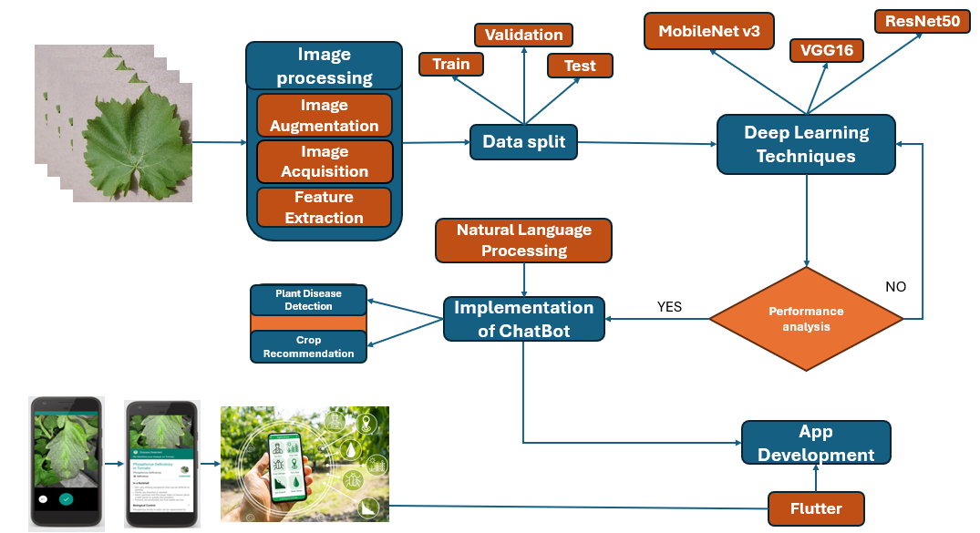
Figure 1 Proposed methodology for plant disease detection
Firstly, the data is collected and then the image preprocessing technique is used in which the features are extracted, image visualization, and image acquisition methods are done.
Then the data set is divided into training and validation sets in the ratio of 7:3. Deep learning techniques like VGG16, ResNet50, and MobileNetV3 are implemented. After considering the results the model performance is analyzed as good by obtaining the training accuracy and validation accuracy for four classes with minimal loss. Then the integration of the chatbot is done through which the queries of the farmers can be solved, this was made by using the Gemini API key. Also, by capturing the image of the leaf the diseases are detected and predictions are given accordingly. If performance meets expectations, results used for app development else models are refined. Chatbot is implemented using NLP to help farmers by providing disease detection results and crop recommendations. The outlook of the system is designed as a mobile app by using flutter that enables users to excess plant disease identification, and suitable crops to be yielded in different kinds of languages.

  - Dataset
Table 1 Dataset description
ATTRIBUTES | DESCRIPTION
Image file type | JPEG, PNG, JPG
No. of images | 76800 (potato, corn, tomato, grape)
split | 7:2:1 (train, test, validation)
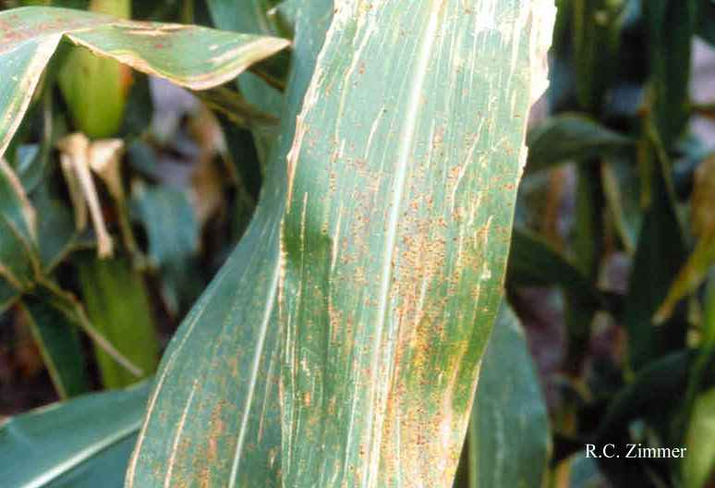
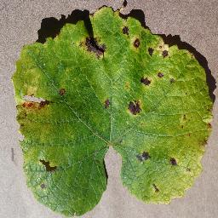
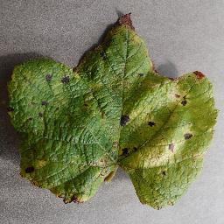
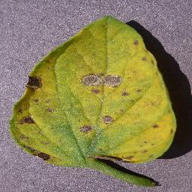
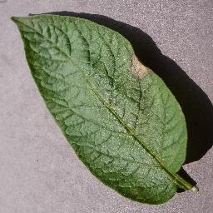
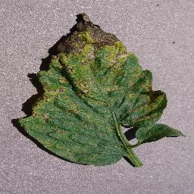
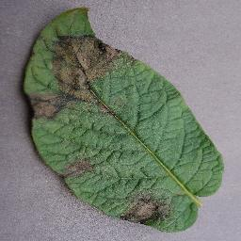
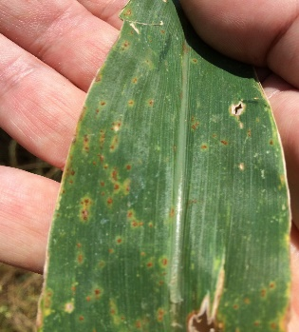
Figure 2 Sample Plant Images
- RESULTS:
Vgg16 which is a pre-trained CNN known for its architecture and high performance in image recognition. For feature extraction, Vgg16 is used because of its ability to capture rich visual features. It achieves high accuracy in identifying diseases for the plants (Corn, grape, tomato, potato). High performance was achieved by each plant model with training and validation accuracy exceeding 90% in most cases. Grape shows the best results, with both training and validation accuracy and minimal loss. Corn and tomato have lower accuracy compared to grapes (94.25% and 92.42% respectively), potato also perform well with an accuracy of 96.17%.

Table 2 Results of model vgg16
plant | Training accuracy | Training loss | Validation accuracy | Validation loss
Corn | 99.75 | 0.0105 | 94.25 | 0.5152
Grape | 99.84 | 0.0028 | 99.37 | 0.0245
Tomato | 98.93 | 0.0341 | 92.42 | 0.5016
Potato | 99.50 | 0.0154 | 96.17 | 0.2159

The performance metrics (precision, recall, f1-score), demonstrated the models' ability to differentiate b/w healthy and disease categories. Grape achieved the highest metrics with precision, recall, and F1- score at 0.99, potato performed well, with a precision of 0.96, recall of 0.94, and F1-score of 0.95. Corn achieves a precision of 0.95 and recall and F1-score of 0.94 whereas tomato achieves a precision of 0.96, recall of 0.94, and F1-score of 0.95. The model evaluated the strong performance overall across all the plants.
Table 3 Performance Metrics
Plant | Precision | Recall | F1-score
Corn | 0.95 | 0.94 | 0.94
Grape | 0.99 | 0.99 | 0.99
Tomato | 0.93 | 0.92 | 0.92
Potato | 0.96 | 0.94 | 0.95

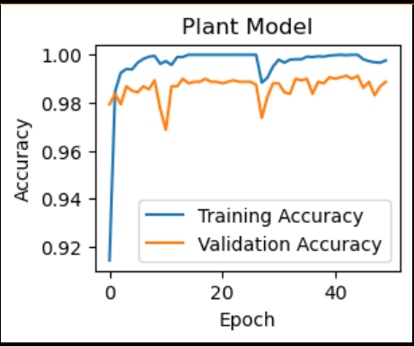
Figure 3 Vgg16 model accuracy
ResNet50 is a deep CNN network that is designed to overcome the vanishing gradient problem in deep networks. ResNet50 achieves high performance, with both training and validation accuracies above 94%. ResNet50 architecture is effectively learning from the dataset. Training and validation loss values are low.

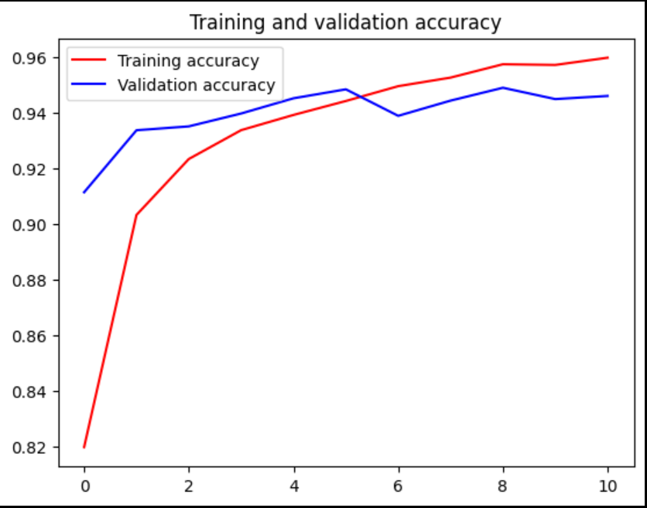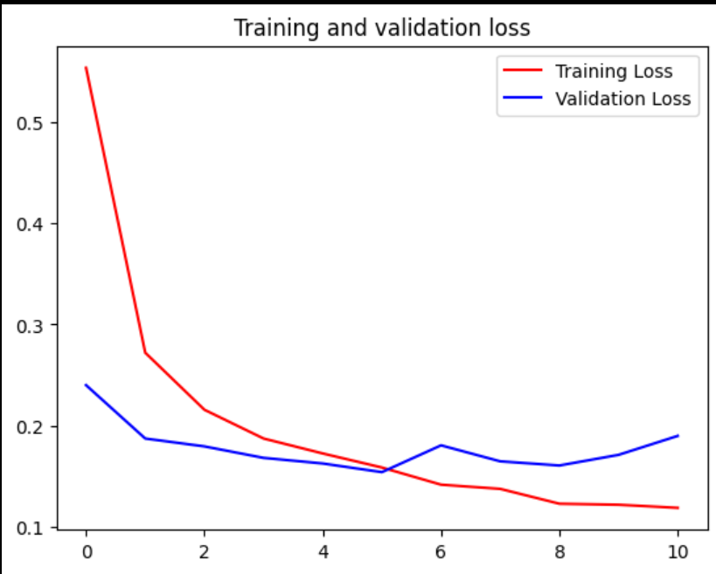
Figure 4 Results of ResNet50
- CONCLUSION AND FUTURE WORK:
KissanDoc successfully demonstrates the potential of integrating ML with mobile to help farmers identify plant diseases and suggest suitable crops to yield. Vgg16 model achieved high accuracy as compared to ResNet 50. The integration of chatbot provides support to ensure farmers by guiding them in their domain i.e. agriculture. The app shows promise in enhancing crop productivity through early disease detection and crop recommendation, empowering farmers with actionable insights and reducing dependency on traditional methods.
Moving forward, there are various options for further research. Increasing the scope of the dataset by including more plant classes will improve the model's robustness and usefulness. Studying more complex deep learning strategies may further increase accuracy. Developing the interface of the chatbot and including more languages that will be feasible for users to understand.
References
[1] A. Kathane, A. Mali, M. Pawar, H. Khairajani, and R. Temkar, “Kissan Konnect-A Smart Farming App,” International Research Journal of Engineering and Technology, 2023, [Online]. Available: www.irjet.net
[2] S. Jain et al., “Automatic Rice Disease Detection and Assistance Framework Using Deep Learning and a Chatbot,” Electronics (Switzerland), vol. 11, no. 14, Jul. 2022, doi: 10.3390/electronics11142110.
[3] R. Susanti, R. Nofendra, Z. Zaini, M. S. A. Bin Suhaimi, and M. I. Rusydi, “The Use of Artificial Neural Networks in Agricultural Plants,” Andalas Journal of Electrical and Electronic Engineering Technology, vol. 2, no. 2, pp. 62–68, Jan. 2023, doi: 10.25077/ajeeet.v2i2.32.
[4] Fruit Disease Detection using Color, Texture Analysis and ANN. IEEE Computer Society, 2015. Accessed: Sep. 26, 2024. [Online]. Available: A. Awate, D. Deshmankar, G. Amrutkar, U. Bagul and S. Sonavane, “Fruit disease detection using color, texture analysis and ANN,” 2015 International Conference on Green Computing and Internet of Things (ICGCIoT), Greater Noida, India, 2015, pp. 970-975, doi: 10.1109/ICGCIoT.2015.7380603
[5] Survey of Plant Disease Detection Using Image Classification Techniques. IEEE, 2020. Accessed: Sep. 26, 2024. [Online]. Available: A. Chhillar, S. Thakur and A. Rana, “Survey of Plant Disease Detection Using Image Classification Techniques,” 2020 8th International Conference on Reliability, Infocom Technologies and Optimization (Trends and Future Directions) (ICRITO), Noida, India, 2020, pp. 1339-1344, doi: 10.1109/ICRITO48877.2020.9197933.
[6] A. Ahmad, D. Saraswat, and A. El Gamal, “A survey on using deep learning techniques for plant disease diagnosis and recommendations for development of appropriate tools,” Feb. 01, 2023, Elsevier B.V. doi: 10.1016/j.atech.2022.100083.
[7] G. Sambasivam and G. D. Opiyo, “A predictive machine learning application in agriculture: Cassava disease detection and classification with imbalanced dataset using convolutional neural networks,” Egyptian Informatics Journal, vol. 22, no. 1, pp. 27–34, Mar. 2021, doi: 10.1016/j.eij.2020.02.007.
[8] “cassava disease dataset.” Accessed: Sep. 20, 2024. [Online]. Available: https://www.kaggle.com/c/cassava-disease/data
[9] Z. Unal, “Smart Farming Becomes even Smarter with Deep Learning - A Bibliographical Analysis,” IEEE Access, vol. 8, pp. 105587–105609, 2020, doi: 10.1109/ACCESS.2020.3000175.
[10] S. P. Mohanty, D. P. Hughes, and M. Salathé, “Using deep learning for image-based plant disease detection,” Front Plant Sci, vol. 7, no. September, Sep. 2016, doi: 10.3389/fpls.2016.01419.
[11] D. Singh, N. Jain, P. Jain, P. Kayal, S. Kumawat, and N. Batra, “PlantDoc: A dataset for visual plant disease detection,” in ACM International Conference Proceeding Series, Association for Computing Machinery, Jan. 2020, pp. 249–253. doi: 10.1145/3371158.3371196.
[12] X. Liu, W. Min, S. Mei, L. Wang, and S. Jiang, “Plant Disease Recognition: A Large-Scale Benchmark Dataset and a Visual Region and Loss Reweighting Approach,” IEEE Transactions on Image Processing, vol. 30, pp. 2003–2015, 2021, doi: 10.1109/TIP.2021.3049334.
[13] D. S. Joseph, P. M. Pawar, and K. Chakradeo, “Real-Time Plant Disease Dataset Development and Detection of Plant Disease Using Deep Learning,” IEEE Access, vol. 12, pp. 16310–16333, 2024, doi: 10.1109/ACCESS.2024.3358333.
[14] D. Geetha, S. Balaji, and S. S. Associate Professor, “Farm’s Smart BOT,” 2021. Accessed: Sep. 26, 2024. [Online]. Available: https://www.proquest.com/openview/0d79004e812233956c45ebc2b27e340a/1?pq-origsite=gscholar&cbl=2045096
[15] AgriBot - An intelligent interactive interface to assist farmers in agricultural activities. IEEE, 2019. Accessed: Sep. 26, 2024. [Online]. Available: D. Sawant, A. Jaiswal, J. Singh and P. Shah, “AgriBot - An intelligent interactive interface to assist farmers in agricultural activities,” 2019 IEEE Bombay Section Signature Conference (IBSSC), Mumbai, India, 2019, pp. 1-6, doi: 10.1109/IBSSC47189.2019.8973066.
[16] S. S. Sannakki, V. S. Rajpurohit, V. B. Nargund, and P. Kulkarni, “Diagnosis and classification of grape leaf diseases using neural networks,” in 2013 4th International Conference on Computing, Communications and Networking Technologies, ICCCNT 2013, 2013. doi: 10.1109/ICCCNT.2013.6726616.
[17] J. D.Pujari, R. Yakkundimath, and Abdulmunaf. S. Byadgi, “SVM and ANN Based Classification of Plant Diseases Using Feature Reduction Technique,” International Journal of Interactive Multimedia and Artificial Intelligence, vol. 3, no. 7, p. 6, 2016, doi: 10.9781/ijimai.2016.371.
[18] M. S. Sivasakthi and M. Phil, “Journal of Analysis and Computation (JAC) (An International Peer Reviewed Journal), www.ijaconline.com, ISSN 0973-2861 International Conference on Artificial Intelligence and Machine learning. PLANT LEAF DISEASE IDENTIFICATION USING IMAGE PROCESSING AND SVM, ANN CLASSIFIER METHODS.” [Online]. Available: www.ijaconline.com,
[19] Diagnosis of Pomegranate Plant Diseases using Neural Network. IEEE, 2015. Accessed: Sep. 26, 2024. [Online]. Available: M. Dhakate and Ingole A. B., “Diagnosis of pomegranate plant diseases using neural network,” 2015 Fifth National Conference on Computer Vision, Pattern Recognition, Image Processing and Graphics (NCVPRIPG), Patna, India, 2015, pp. 1-4, doi: 10.1109/NCVPRIPG.2015.7490056.
[20] N. Upadhyay and N. Gupta, “A Survey on Diseases Detection for Agriculture Crops Using Artificial Intelligence,” in 2021 5th International Conference on Information Systems and Computer Networks, ISCON 2021, Institute of Electrical and Electronics Engineers Inc., 2021. doi: 10.1109/ISCON52037.2021.9702513.

